# Hazardous Goods Shipping Baggies/Stickers

Stickers

Baggies

Shipper’s Declaration for Dangerous Goods

FAQs

Safety Data Sheets (SDS)

Related Documents

**Description:** This job aid covers the shipping stickers used for hazardous goods.

|  |
| --- |
| Stickers |

Hazardous goods will ship with stickers affixed to the shipping package.

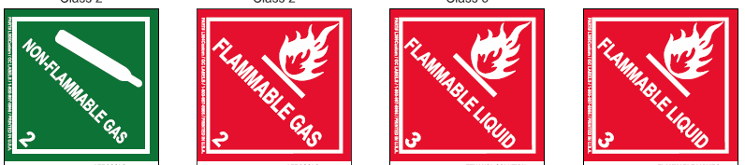

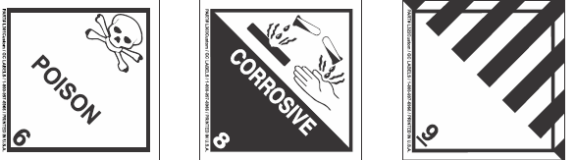

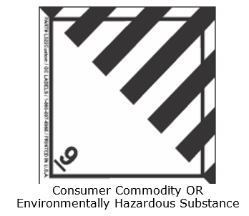

**Figure A:** 4X5 Custom Roll Stickers

Top of the Document

|  |
| --- |
| Baggies |

Hazardous goods will ship in a Hazardous Drug baggie.

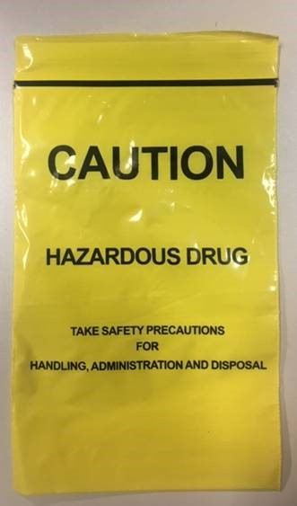

**Figure B:** Hazardous Drug Baggie

Top of the Document

|  |
| --- |
| Shipper’s Declaration for Dangerous Goods |

A **Shipper’s Declaration for Dangerous Goods** is included with every shipment. This document gives the description of the dangerous goods.

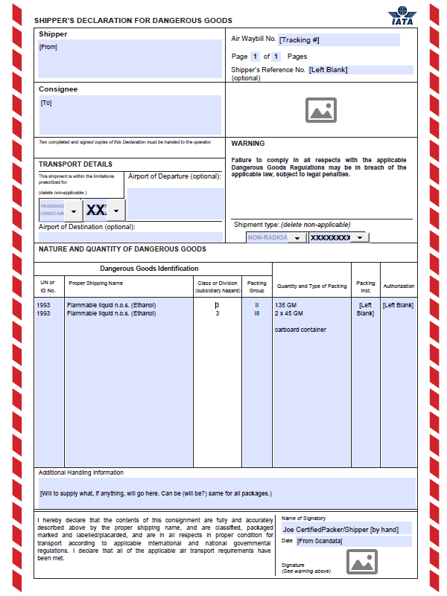

**Figure C:** Shipper’s Declaration for Dangerous Goods

Top of the Document

|  |
| --- |
| FAQs |

The following are answers to questions frequently asked by members:

**Q: Did my medication change? I have not seen this sticker/baggie before.**

 No, the drug you have been receiving is still the same; there is no change to your medication. The medication you receive has been identified by our pharmacy because it may have special handling and/or disposal requirements, and it is our goal to share this information with you and your caregiver, as applicable. The baggie/sticker are meant to provide awareness.

**Q: Can you stop putting my medication in the baggie/leave the sticker off the package?**

 The baggie/sticker is intended to draw your attention to the drug for proper handling and disposal and the important information included inside the package. We do not have the ability to not use the baggie or sticker on request.

**Q: What is the proper way to handle a drug that comes in one of these baggies?**

 If you should notice that anything has leaked or is outside of the prescription container(s), you would want to leave it in the bag (do not open the baggie). You can handle all intact tablets and capsules as usual, but if a capsule or tablet is damaged, do not try to clean off the residue or touch the remaining drugs in the container, instead we will re-ship you a new order.

**Q: What am I to do with leftover medication or medication that I am no longer taking?**

 We **do not** recommend that you flush any leftover or unwanted medication down the drain or toilet. The U.S. Food and Drug Administration offers a list of medicines that can be flushed if no other option is available. Disposing of unused or unneeded prescription drugs can be accomplished by learning about drug take back or drug disposal options in your community. You can also do things at home to make the medicines safe to dispose of in the trash.

**Q: When you say “proper disposal of medication,” what do you mean?**

 Drugs should not be flushed down the toilet. In most cases, removing the drug from the prescription bottle/container and mixing the drugs into dirt, coffee grounds, or cat litter is a good first in disposal. Other products like patches should be folded upon itself, so that any remaining medication on the patch cannot be touched, and then disposed of in the trash.

**Q:** **Why is one of my drugs in a baggie and my other drugs are not in a baggie?**

 Medication you received in a baggie has been identified as one that may require special handling and/or disposal, and it is our goal to share this information with you and your caregiver, as applicable. The baggie/sticker are meant to provide awareness.

**Q:** **Where can I find out more information about proper handling and disposal instructions?**

 You can use the package insert to see the manufacturer specific handling and disposal instructions. If you do not have the package insert, or you can visit the FDA website OR EPA website for more information.

* + **FDA:**

<https://www.fda.gov/consumers/consumer-updates/where-and-how-dispose-unused-medicines#:~:text=Drug%20Take%20Back%20Programs&text=Check%20with%20your%20local%20law,disposal%20kiosks%20for%20unused%20medicines.>

* + **EPA:**

<https://www.epa.gov/hwgenerators/collecting-and-disposing-unwanted-medicines#:~:text=EPA%20encourages%20the%20public%20to,to%20dispose%20of%20unwanted%20medicines>.

Top of the Document

|  |
| --- |
| Safety Data Sheets (SDS) |

The Hazard Communication Standard (HCS) requires chemical manufacturers, distributors, or importers to use Safety Data Sheets (SDS) (formerly known as Material Safety Data Sheets or MSDS) to communicate the hazards of hazardous chemical products.

The hotline number, **1-888-464-2960**, is available when SDS information is needed. The information will be conveyed over the phone or can be faxed.

Top of the Document

|  |
| --- |
| Related Documents |

[Shipping Guidelines and Fees (004611)](https://thesource.cvshealth.com/nuxeo/thesource/#!/view?docid=49a324cd-73b1-4e49-bdae-9ac58e18d184)

[Cold Pack Packages (068152)](https://thesource.cvshealth.com/nuxeo/thesource/#!/view?docid=42b8115d-45ff-4172-9bc4-f3e0a26bde02)

[Order Shipping Turn Around Time (018691)](https://thesource.cvshealth.com/nuxeo/thesource/#!/view?docid=3338f261-4696-4e84-9019-43cc2eef3352)

[Customer Care Abbreviations, Definitions, and Terms (017428)](https://thesource.cvshealth.com/nuxeo/thesource/#!/view?docid=c1f1028b-e42c-4b4f-a4cf-cc0b42c91606)

Top of the Document

Not to Be Reproduced or Disclosed to Others without Prior Written Approval

**ELECTRONIC DATA = OFFICIAL VERSION / PAPER COPY = INFORMATIONAL ONLY**